Приложение

Описание местоположения границ публичного сервитута

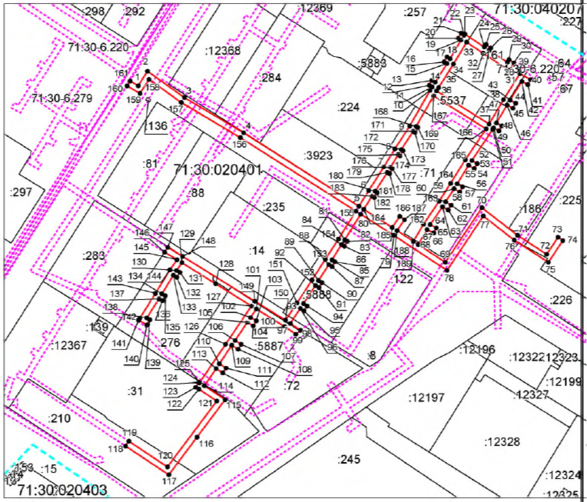

Масштаб 1:2300

Ведомость координат поворотных точек

@ 134199
Обозначение характерных точек границ | Координаты. м
Обозначение характерных точек границ | X | Y
1 | 740958.34 | 259992.90
2 | 740968.36 | 259999.36
3 | 740950.08 | 260024.80
4 | 740925.82 | 260065.53
5 | 740874.93 | 260145.16
6 | 740885.73 | 260151.91
7 | 740902.04 | 260162.30
8 | 740914.56 | 260169.90
9 | 740930.41 | 260180.15
10 | 740955.08 | 260194.20
11 | 740957.41 | 260195.63
12 | 740958.57 | 260193.60
13 | 740962.04 | 260195.59
14 | 740960.80 | 260197.74
15 | 740973.62 | 260205.83
16 | 740974.79 | 260203.82
17 | 740978.25 | 260205.83
18 | 740977.03 | 260207.93
19 | 740989.91 | 260215.63
20 | 740991.15 | 260213.57
21 | 740994.58 | 260215.63
22 | 740993.35 | 260217.69
23 | 740994.07 | 260218.11
24 | 740985.10 | 260231.53
25 | 740986.86 | 260232.80
26 | 740984.51 | 260236.04
27 | 740982.88 | 260234.86
28 | 740974.52 | 260247.42
29 | 740976.27 | 260248.60
30 | 740974.04 | 260251.92
31 | 740968.98 | 260248.53
32 | 740980.70 | 260230.91
33 | 740988.37 | 260219.37
34 | 740973.25 | 260210.33
35 | 740957.06 | 260200.11
36 | 740954.70 | 260198.66
37 | 740931.85 | 260234.92
38 | 740948.65 | 260244.83
39 | 740966.61 | 260256.10
40 | 740962.59 | 260263.45
41 | 740959.08 | 260261.53
42 | 740961.29 | 260257.48
43 | 740948.35 | 260249.36
44 | 740946.27 | 260253.20
45 | 740942.75 | 260251.30
46 | 740944.93 | 260247.28
47 | 740932.59 | 260239.97
48 | 740930.60 | 260243.57
49 | 740927.10 | 260241.63
50 | 740929.13 | 260237.99
51 | 740927.99 | 260237.35
52 | 740906.64 | 260222.99
53 | 740904.50 | 260226.68
54 | 740901.04 | 260224.67
55 | 740903.27 | 260220.81
56 | 740890.42 | 260212.84
57 | 740888.28 | 260216.59
58 | 740884.81 | 260214.61
59 | 740887.03 | 260210.71
60 | 740877.95 | 260204.92
61 | 740875.75 | 260208.65
62 | 740872.30 | 260206.62
63 | 740874.60 | 260202.73
64 | 740862.20 | 260194.32
65 | 740859.92 | 260198.50
66 | 740856.41 | 260196.58
67 | 740858.82 | 260192.16
68 | 740848.46 | 260186.01
69 | 740836.07 | 260204.75
70 | 740873.90 | 260229.90
71 | 740854.80 | 260254.57
72 | 740841.65 | 260274.65
73 | 740853.42 | 260282.36
74 | 740851.22 | 260285.71
75 | 740836.11 | 260275.81
76 | 740851.54 | 260252.24
77 | 740868.10 | 260230.86
78 | 740830.53 | 260205.87
79 | 740854.84 | 260169.16
80 | 740869.42 | 260146.35
81 | 740851.82 | 260135.42
82 | 740850.61 | 260137.28
83 | 740847.25 | 260135.10
84 | 740848.44 | 260133.28
85 | 740837.91 | 260126.52
86 | 740836.63 | 260128.60
87 | 740833.22 | 260126.50
88 | 740834.54 | 260124.35
89 | 740823.54 | 260117.28
90 | 740822.11 | 260119.61
91 | 740818.70 | 260117.52
92 | 740820.18 | 260115.11
93 | 740807.60 | 260106.92
94 | 740805.97 | 260109.43
95 | 740802.62 | 260107.25
96 | 740804.26 | 260104.72
97 | 740793.88 | 260097.80
98 | 740789.10 | 260104.85
99 | 740786.49 | 260101.57
100 | 740791.67 | 260093.94
101 | 740803.86 | 260074.45
102 | 740797.96 | 260070.47
103 | 740795.67 | 260074.33
104 | 740792.23 | 260072.30
105 | 740794.63 | 260068.24
106 | 740782.05 | 260059.76
107 | 740779.45 | 260063.96
108 | 740776.05 | 260061.86
109 | 740778.72 | 260057.53
110 | 740765.97 | 260048.94
111 | 740762.99 | 260053.47
112 | 740759.64 | 260051.28
113 | 740762.65 | 260046.70
114 | 740750.70 | 260038.65
115 | 740741.23 | 260052.88
116 | 740715.23 | 260033.46
117 | 740689.23 | 260014.03
118 | 740709.11 | 259984.15
119 | 740712.36 | 259986.49
120 | 740694.66 | 260013.09
121 | 740740.24 | 260047.15
122 | 740748.45 | 260034.82
123 | 740749.77 | 260032.69
124 | 740753.17 | 260034.79
125 | 740752.86 | 260035.29
126 | 740779.48 | 260053.21
127 | 740805.98 | 260071.05
128 | 740821.35 | 260046.38
129 | 740835.84 | 260023.13
130 | 740830.48 | 260019.43
131 | 740829.20 | 260021.62
132 | 740825.75 | 260019.61
133 | 740827.13 | 260017.23
134 | 740814.37 | 260009.33
135 | 740813.01 | 260011.62
136 | 740809.57 | 260009.58
137 | 740810.97 | 260007.21
138 | 740797.61 | 259998.85
139 | 740796.39 | 260000.95
140 | 740792.93 | 259998.95
141 | 740796.20 | 259993.28
142 | 740797.50 | 259994.08
143 | 740814.74 | 260004.86
144 | 740830.94 | 260014.88
145 | 740837.94 | 260019.72
146 | 740843.17 | 260011.14
147 | 740846.52 | 260013.33
148 | 740840.25 | 260023.61
149 | 740809.25 | 260073.37
150 | 740796.07 | 260094.45
151 | 740808.12 | 260102.48
152 | 740823.98 | 260112.81
153 | 740838.13 | 260121.90
154 | 740852.28 | 260130.99
155 | 740871.54 | 260143.03
156 | 740922.41 | 260063.43
157 | 740946.73 | 260022.61
158 | 740962.65 | 260000.44
159 | 740952.95 | 259994.18
160 | 740958.18 | 259985.28
161 | 740961.56 | 259987.43
1 | 740958.34 | 259992.90
162 | 740862.57 | 260189.74
163 | 740878.37 | 260200.45
164 | 740890.78 | 260208.35
165 | 740907.06 | 260218.45
166 | 740928.44 | 260232.83
167 | 740951.25 | 260196.63
168 | 740930.14 | 260184.59
169 | 740929.53 | 260185.68
170 | 740926.04 | 260183.73
171 | 740926.71 | 260182.52
172 | 740914.10 | 260174.36
173 | 740913.31 | 260175.58
174 | 740909.95 | 260173.42
175 | 740910.71 | 260172.24
176 | 740901.75 | 260166.80
177 | 740901.05 | 260168.11
178 | 740897.52 | 260166.23
179 | 740898.35 | 260164.69
180 | 740885.31 | 260156.39
181 | 740884.41 | 260157.80
182 | 740881.02 | 260155.76
183 | 740881.99 | 260154.15
184 | 740872.82 | 260148.46
185 | 740860.30 | 260168.05
186 | 740867.85 | 260173.21
187 | 740865.59 | 260176.52
188 | 740858.12 | 260171.40
189 | 740850.67 | 260182.67
162 | 740862.57 | 260189.74
