Приложение

Описание местоположения границ публичного сервитута

**Основной лист**

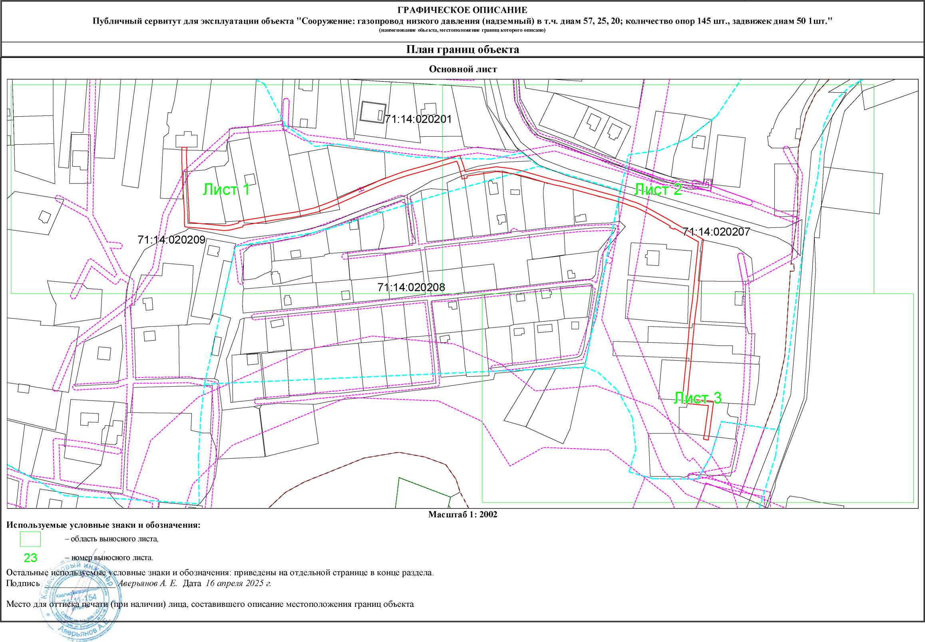

Масштаб 1:2002

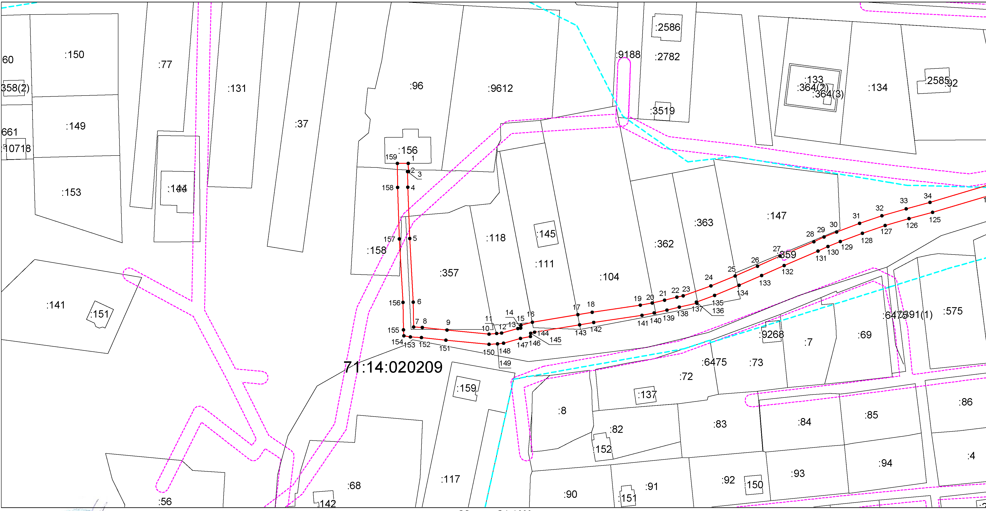

Масштаб 1:1000

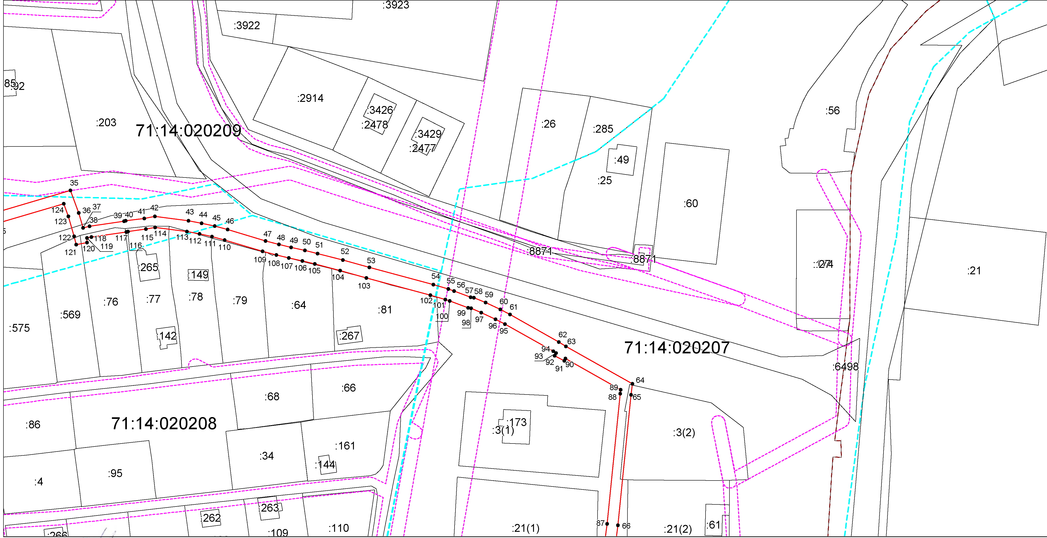

Масштаб 1:1000

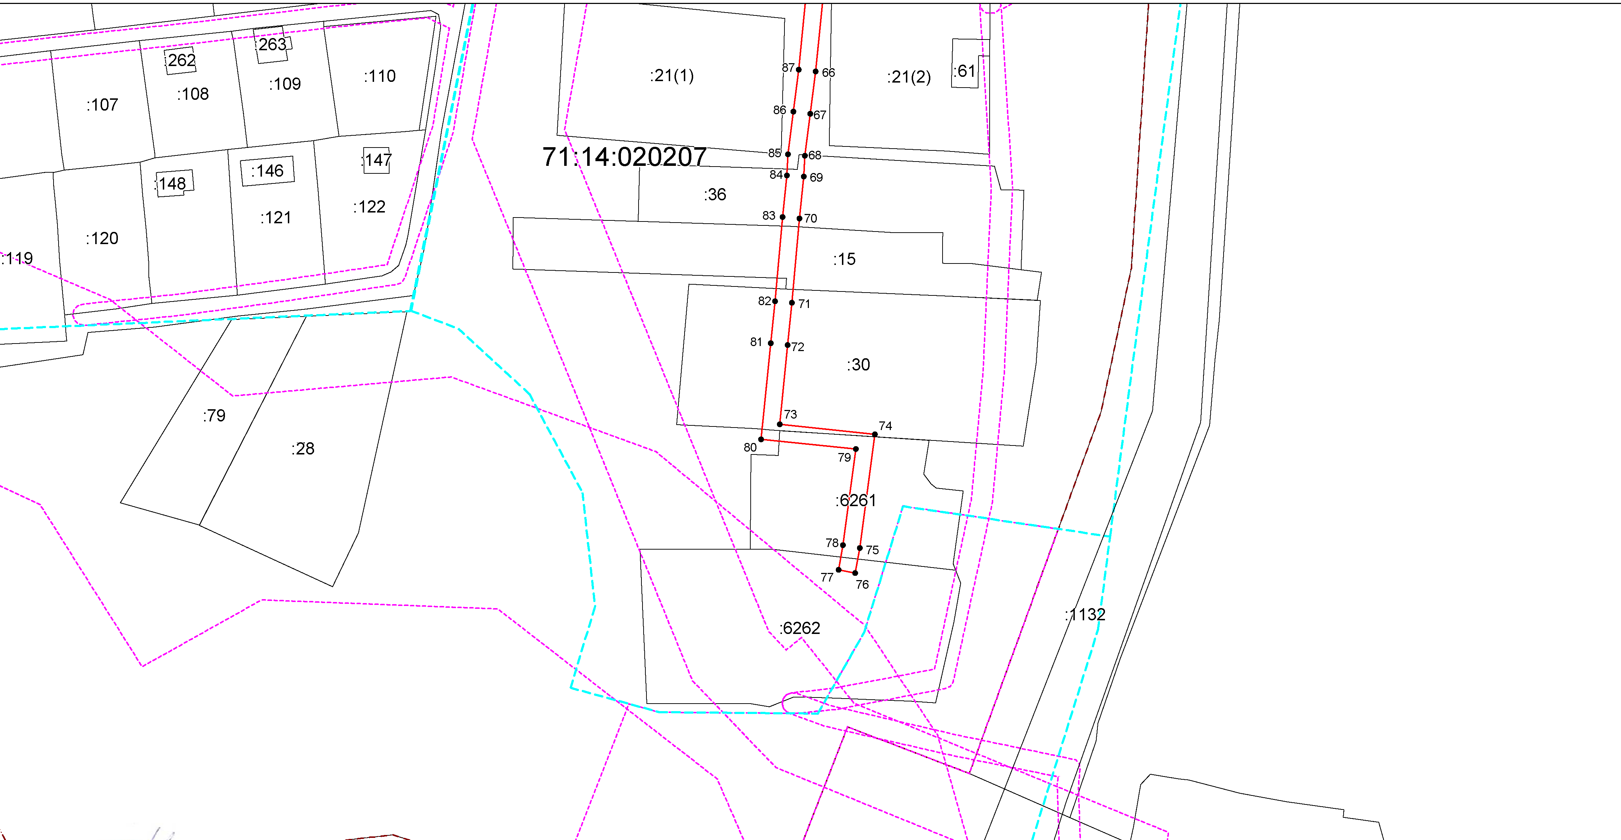

Масштаб 1:1000

**Условные обозначения:**

- граница объекта,

- установленная граница муниципального образования,

- установленная граница населенного пункта,

- граница земельного участка,

 - характерная точка объекта.

Ведомость координат поворотных точек

|  |  |  |
| --- | --- | --- |
| @138880 | | |
| Обозначение характерных точек границ | Координаты | |
| X | Y |
| 1 | 754809.35 | 270659.07 |
| 2 | 754806.08 | 270659.09 |
| 3 | 754806.08 | 270658.83 |
| 4 | 754799.98 | 270658.88 |
| 5 | 754779.95 | 270659.60 |
| 6 | 754755.09 | 270660.96 |
| 7 | 754745.35 | 270661.19 |
| 8 | 754745.13 | 270664.51 |
| 9 | 754744.10 | 270674.23 |
| 10 | 754742.53 | 270690.62 |
| 11 | 754742.74 | 270693.61 |
| 12 | 754742.93 | 270695.57 |
| 13 | 754744.68 | 270701.92 |
| 14 | 754744.90 | 270703.01 |
| 15 | 754745.96 | 270703.10 |
| 16 | 754747.19 | 270707.56 |
| 17 | 754750.11 | 270725.32 |
| 18 | 754751.04 | 270730.89 |
| 19 | 754753.85 | 270749.70 |
| 20 | 754754.73 | 270754.34 |
| 21 | 754755.79 | 270759.19 |
| 22 | 754756.97 | 270764.00 |
| 23 | 754757.51 | 270766.43 |
| 24 | 754761.43 | 270777.31 |
| 25 | 754765.29 | 270786.77 |
| 26 | 754769.10 | 270795.52 |
| 27 | 754773.04 | 270804.28 |
| 28 | 754778.69 | 270817.53 |
| 29 | 754780.50 | 270821.47 |
| 30 | 754782.45 | 270826.39 |
| 31 | 754785.85 | 270835.36 |
| 32 | 754788.82 | 270844.12 |
| 33 | 754791.55 | 270853.59 |
| 34 | 754794.07 | 270862.86 |
| 35 | 754802.32 | 270890.69 |
| 36 | 754793.95 | 270893.74 |
| 37 | 754788.51 | 270895.31 |
| 38 | 754789.05 | 270897.70 |
| 39 | 754790.90 | 270910.41 |
| 40 | 754791.07 | 270910.99 |
| 41 | 754791.99 | 270917.86 |
| 42 | 754792.72 | 270921.75 |
| 43 | 754791.13 | 270934.11 |
| 44 | 754790.22 | 270938.99 |
| 45 | 754789.14 | 270943.75 |
| 46 | 754787.86 | 270948.54 |
| 47 | 754783.70 | 270962.47 |
| 48 | 754782.36 | 270967.41 |
| 49 | 754781.27 | 270971.89 |
| 50 | 754780.19 | 270976.92 |
| 51 | 754779.04 | 270981.59 |
| 52 | 754776.66 | 270990.90 |
| 53 | 754773.92 | 271000.68 |
| 54 | 754767.54 | 271024.18 |
| 55 | 754765.96 | 271029.67 |
| 56 | 754765.20 | 271031.80 |
| 57 | 754762.90 | 271037.95 |
| 58 | 754762.74 | 271039.13 |
| 59 | 754760.94 | 271043.45 |
| 60 | 754758.41 | 271048.86 |
| 61 | 754756.56 | 271052.41 |
| 62 | 754746.43 | 271070.34 |
| 63 | 754744.80 | 271072.98 |
| 64 | 754730.97 | 271097.45 |
| 65 | 754726.94 | 271096.93 |
| 66 | 754678.88 | 271092.08 |
| 67 | 754668.92 | 271090.78 |
| 68 | 754659.00 | 271089.58 |
| 69 | 754654.04 | 271089.28 |
| 70 | 754644.16 | 271088.26 |
| 71 | 754624.26 | 271086.52 |
| 72 | 754614.30 | 271085.45 |
| 73 | 754595.59 | 271083.63 |
| 74 | 754593.25 | 271106.08 |
| 75 | 754566.40 | 271102.51 |
| 76 | 754560.41 | 271101.39 |
| 77 | 754561.24 | 271097.47 |
| 78 | 754567.03 | 271098.56 |
| 79 | 754589.70 | 271101.57 |
| 80 | 754592.02 | 271079.26 |
| 81 | 754614.71 | 271081.47 |
| 82 | 754624.65 | 271082.54 |
| 83 | 754644.54 | 271084.28 |
| 84 | 754654.36 | 271085.29 |
| 85 | 754659.36 | 271085.60 |
| 86 | 754669.42 | 271086.81 |
| 87 | 754679.34 | 271088.11 |
| 88 | 754727.40 | 271092.95 |
| 89 | 754728.81 | 271093.13 |
| 90 | 754740.31 | 271072.79 |
| 91 | 754739.49 | 271072.36 |
| 92 | 754741.31 | 271068.81 |
| 93 | 754742.35 | 271069.34 |
| 94 | 754742.99 | 271068.31 |
| 95 | 754753.04 | 271050.51 |
| 96 | 754754.82 | 271047.09 |
| 97 | 754757.28 | 271041.83 |
| 98 | 754758.85 | 271038.08 |
| 99 | 754759.00 | 271036.97 |
| 100 | 754761.53 | 271030.22 |
| 101 | 754762.10 | 271028.62 |
| 102 | 754763.69 | 271023.10 |
| 103 | 754770.07 | 270999.60 |
| 104 | 754772.78 | 270989.90 |
| 105 | 754775.17 | 270980.59 |
| 106 | 754776.29 | 270976.03 |
| 107 | 754777.37 | 270971.00 |
| 108 | 754778.48 | 270966.42 |
| 109 | 754779.86 | 270961.37 |
| 110 | 754784.01 | 270947.45 |
| 111 | 754785.26 | 270942.79 |
| 112 | 754786.30 | 270938.18 |
| 113 | 754787.17 | 270933.49 |
| 114 | 754788.67 | 270921.87 |
| 115 | 754788.04 | 270918.49 |
| 116 | 754787.15 | 270911.85 |
| 117 | 754786.98 | 270911.30 |
| 118 | 754785.11 | 270898.43 |
| 119 | 754784.74 | 270896.79 |
| 120 | 754783.04 | 270896.80 |
| 121 | 754782.27 | 270892.77 |
| 122 | 754785.35 | 270892.06 |
| 123 | 754792.71 | 270889.94 |
| 124 | 754797.41 | 270888.22 |
| 125 | 754790.21 | 270863.93 |
| 126 | 754787.70 | 270854.69 |
| 127 | 754785.00 | 270845.33 |
| 128 | 754782.01 | 270836.52 |
| 129 | 754778.72 | 270827.84 |
| 130 | 754776.82 | 270823.04 |
| 131 | 754775.04 | 270819.15 |
| 132 | 754769.37 | 270805.89 |
| 133 | 754765.44 | 270797.14 |
| 134 | 754761.61 | 270788.32 |
| 135 | 754757.71 | 270778.76 |
| 136 | 754755.09 | 270771.64 |
| 137 | 754754.63 | 270771.84 |
| 138 | 754753.07 | 270764.92 |
| 139 | 754751.89 | 270760.09 |
| 140 | 754750.81 | 270755.14 |
| 141 | 754749.91 | 270750.37 |
| 142 | 754747.09 | 270731.51 |
| 143 | 754746.16 | 270725.97 |
| 144 | 754743.28 | 270708.41 |
| 145 | 754742.85 | 270706.85 |
| 146 | 754741.59 | 270706.75 |
| 147 | 754740.79 | 270702.86 |
| 148 | 754738.98 | 270696.30 |
| 149 | 754738.75 | 270693.94 |
| 150 | 754738.51 | 270690.58 |
| 151 | 754740.13 | 270673.79 |
| 152 | 754741.14 | 270664.20 |
| 153 | 754741.43 | 270659.86 |
| 154 | 754741.80 | 270657.38 |
| 155 | 754744.19 | 270657.21 |
| 156 | 754754.93 | 270656.97 |
| 157 | 754779.78 | 270655.61 |
| 158 | 754799.88 | 270654.88 |
| 159 | 754809.32 | 270654.84 |
| 1 | 754809.35 | 270659.07 |